MOST IMPORTANT COMMANDS YOU MUST MEMORIZE

PC Commands
ipconfig
ping 192.168.1.1
tracert 192.168.2.1

Router Commands
enable
configure terminal

interface gig0/0
ip address 192.168.1.1 255.255.255.0
no shutdown
exit

interface gig0/1
ip address 192.168.2.1 255.255.255.0
no shutdown
exit

ip route 192.168.3.0 255.255.255.0 10.0.0.2

show ip route
show running-config
show ip interface brief

Switch Commands
enable
show mac-address-table
show running-config

IMPORTANT TOPOLOGIES

Star Topology
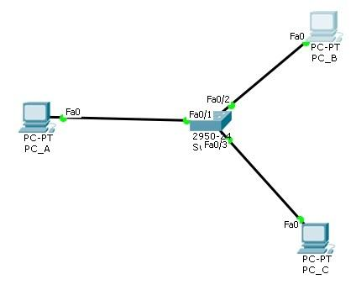
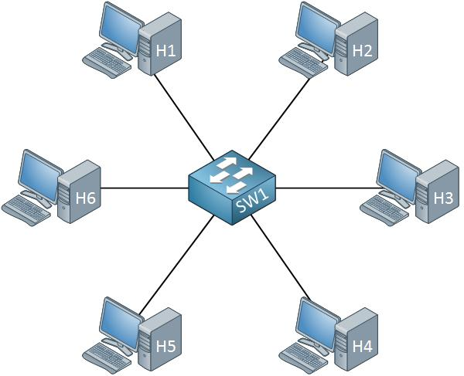
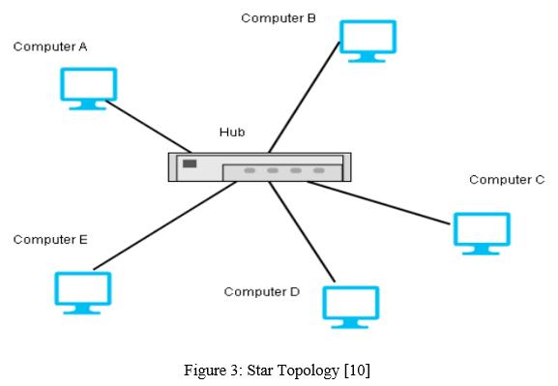
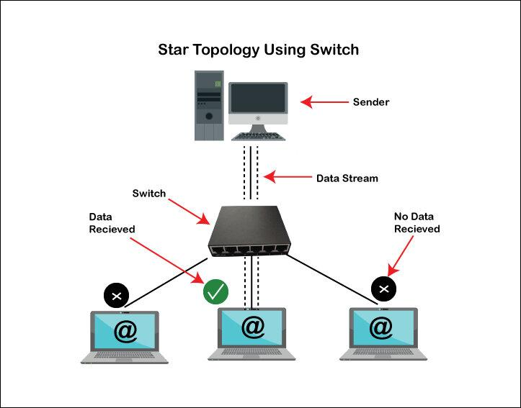
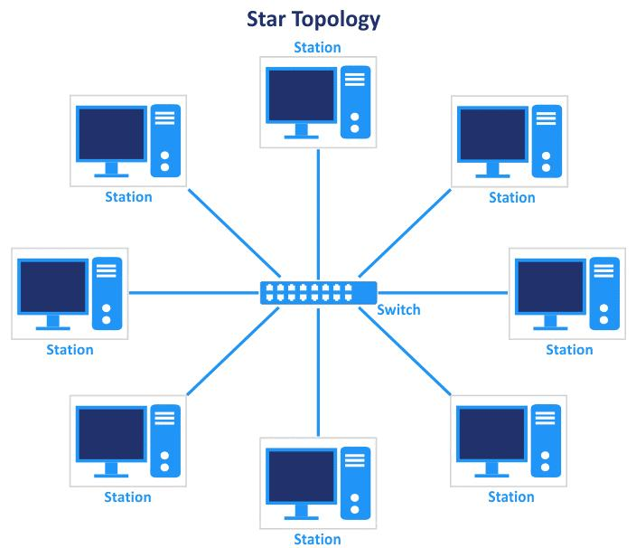
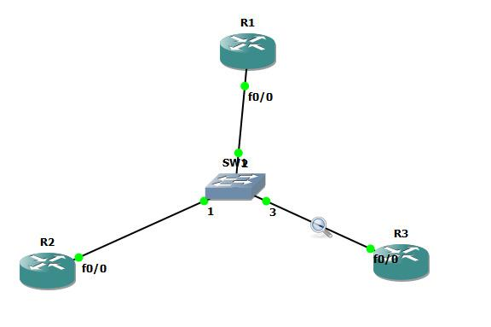
- One switch in center
- All PCs connected to switch
- Most common in Packet Tracer

Bus Topology
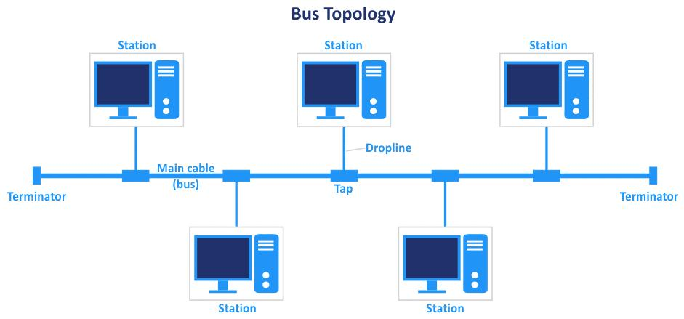
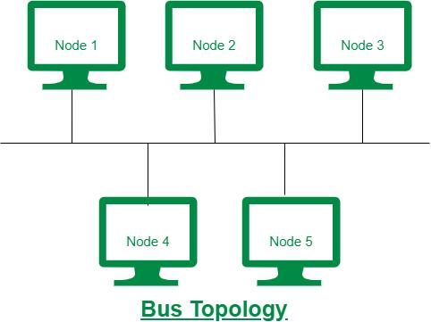
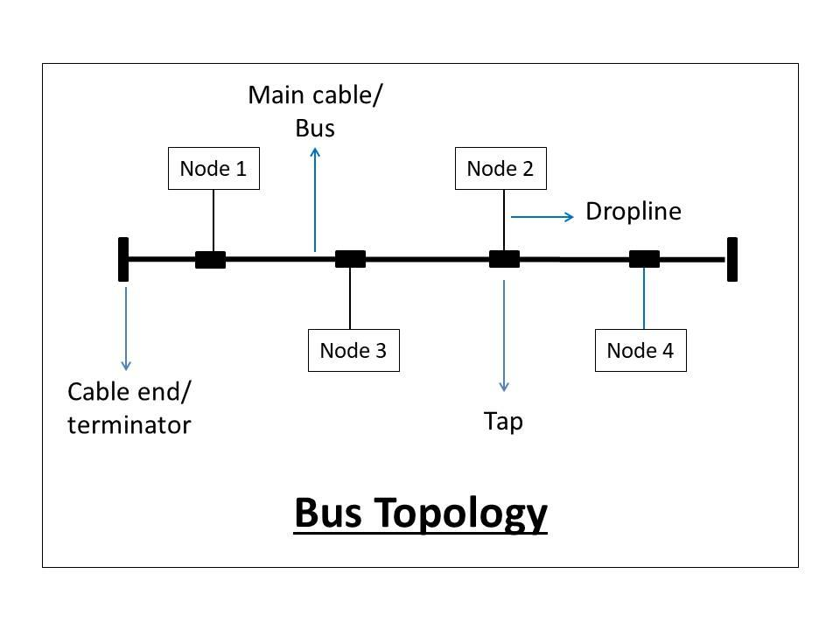
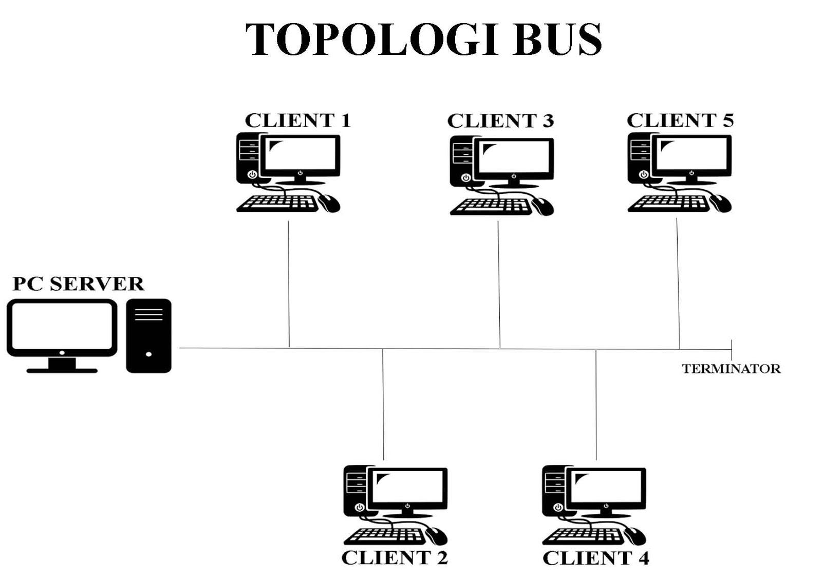
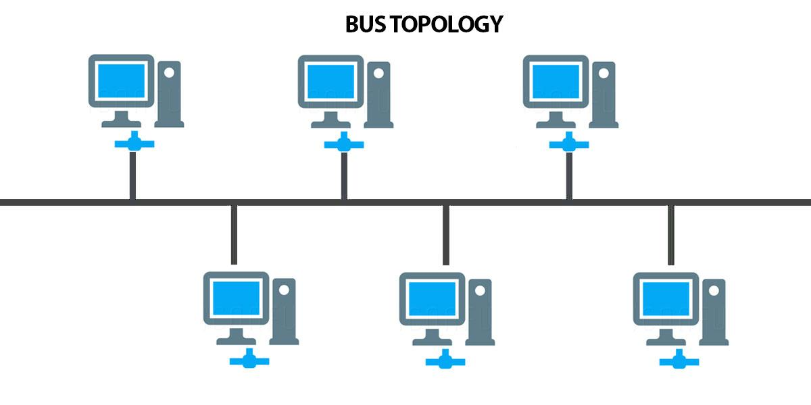
- Single backbone cable
- Rare practically in Packet Tracer
- Mostly theoretical

Ring Topology
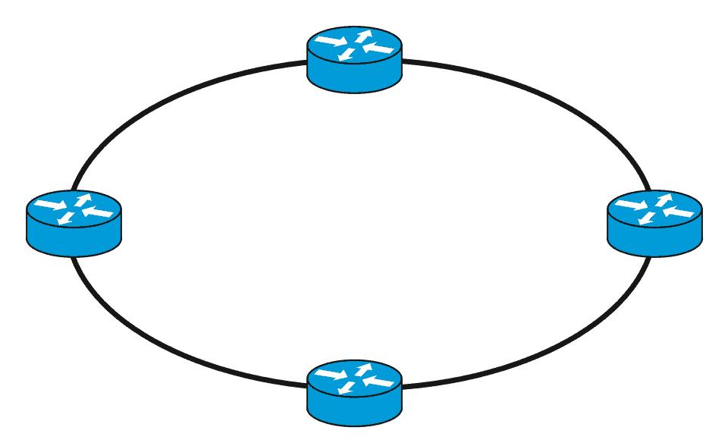
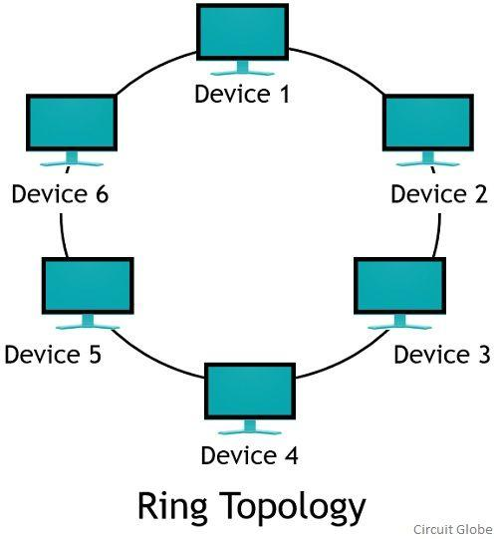
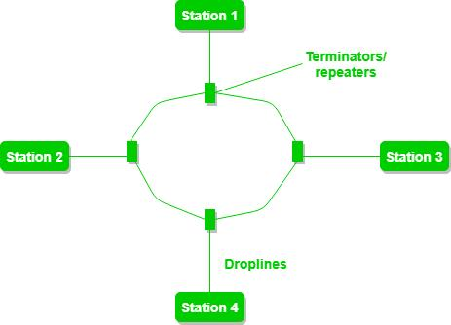
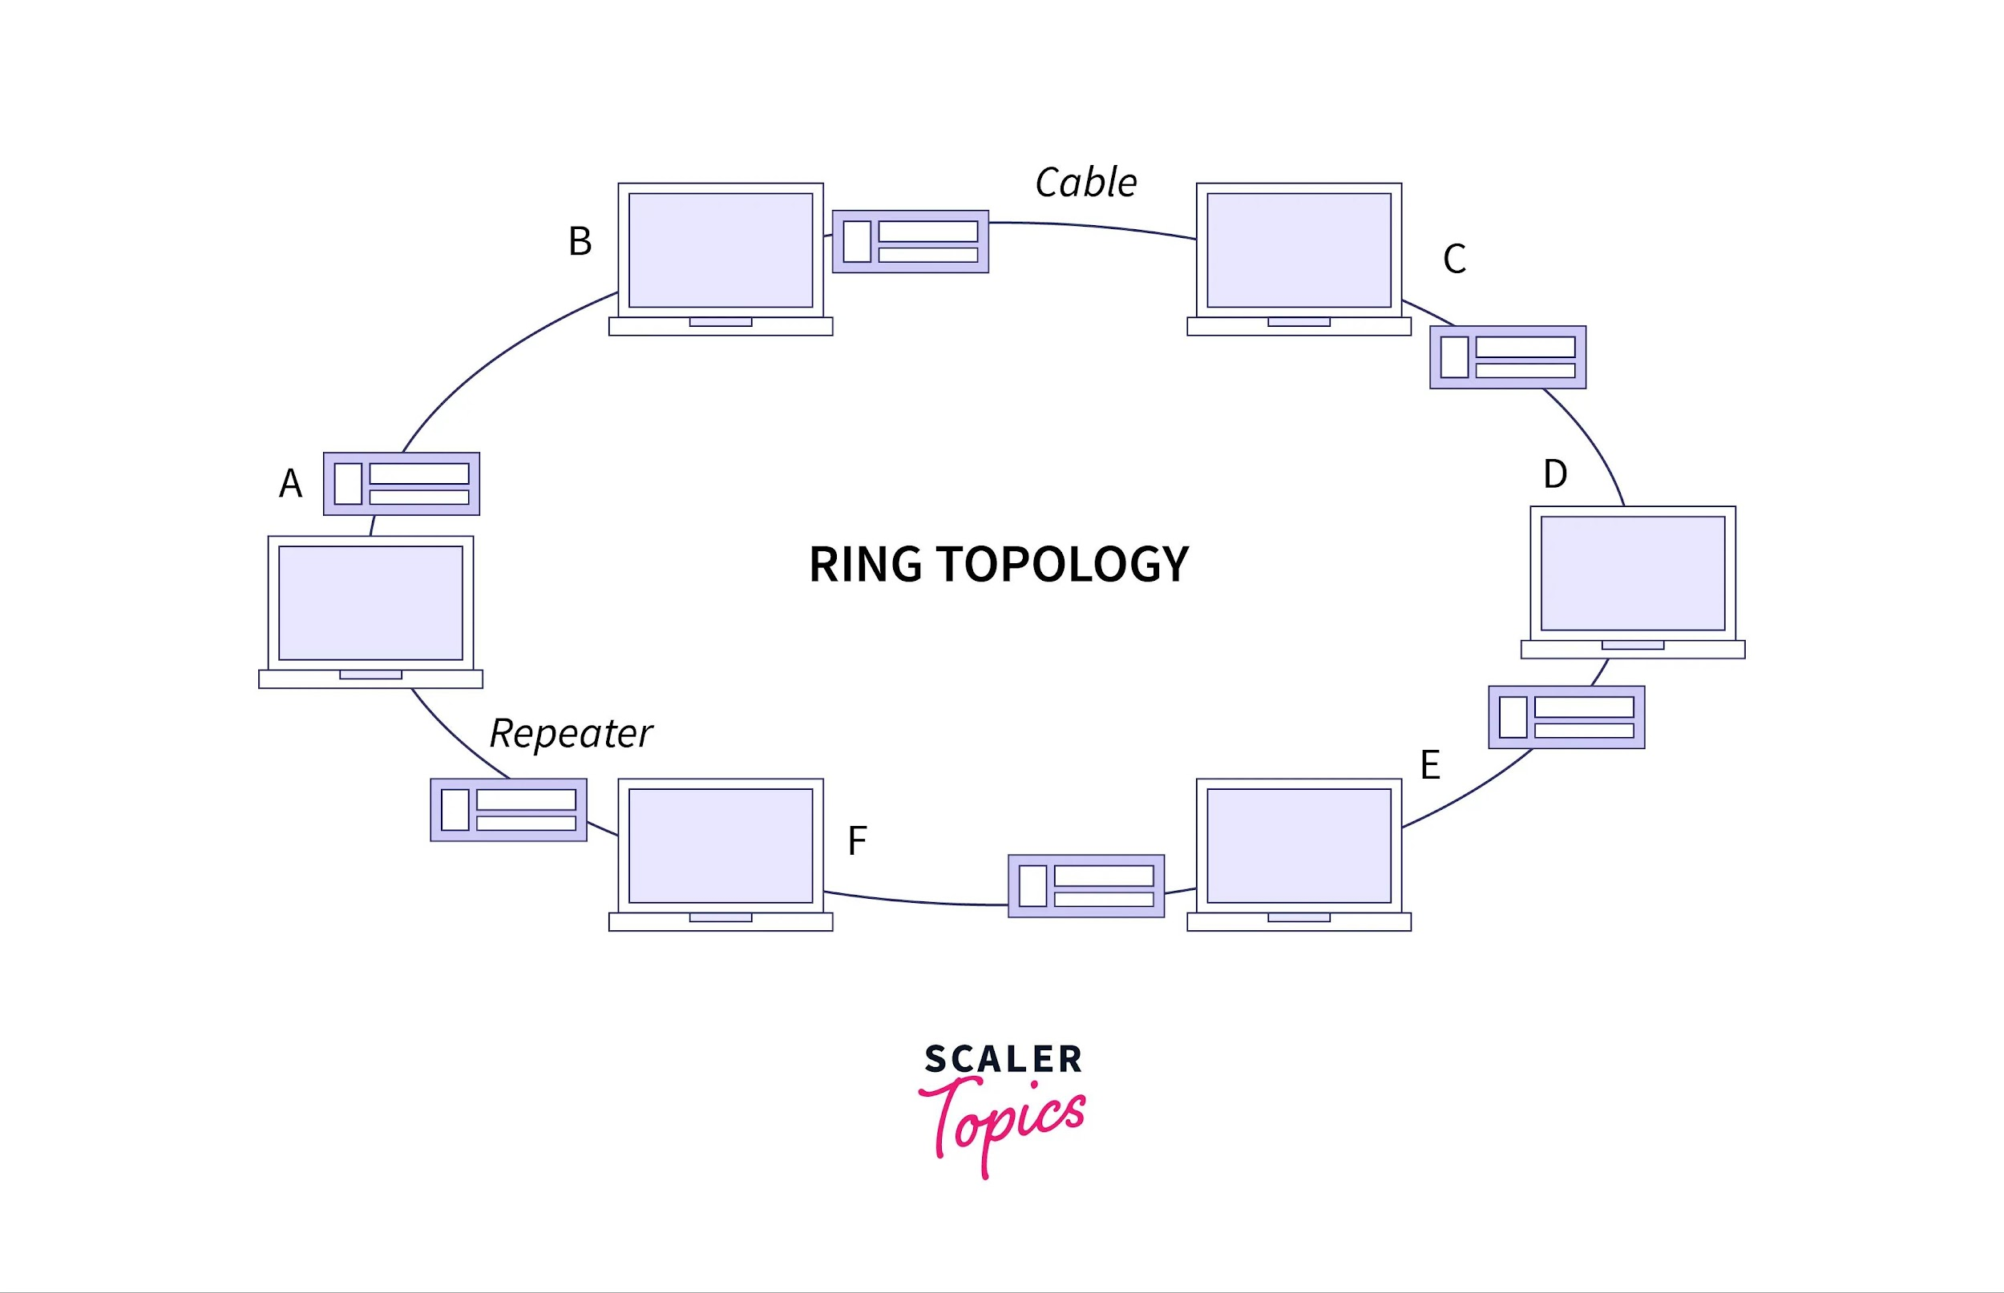
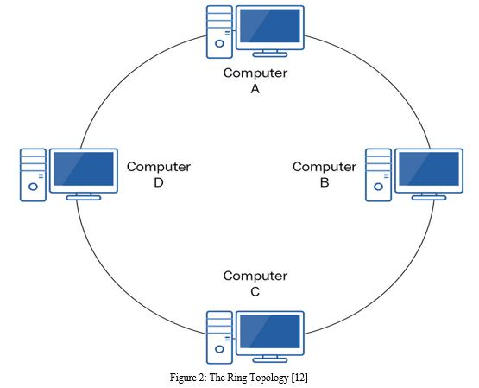
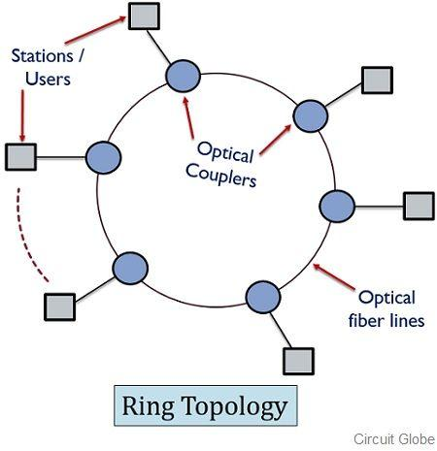
- Devices connected in circular form

Mesh Topology
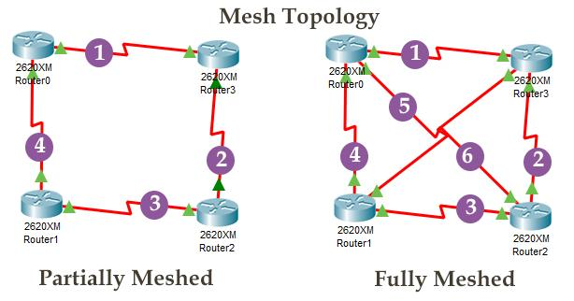
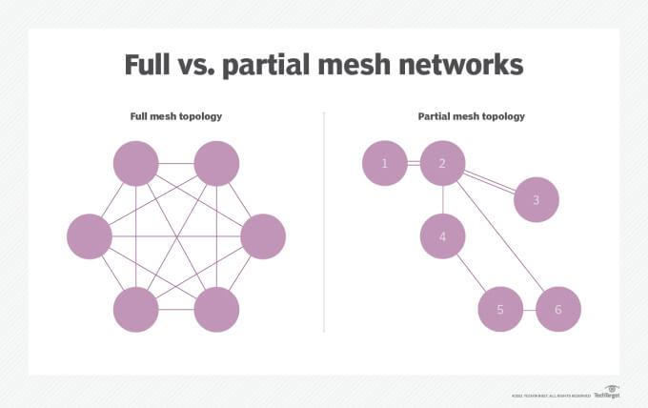
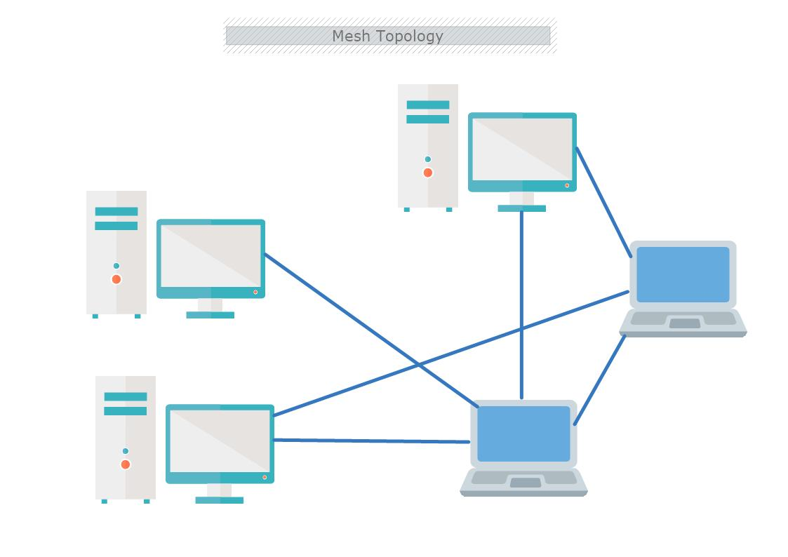
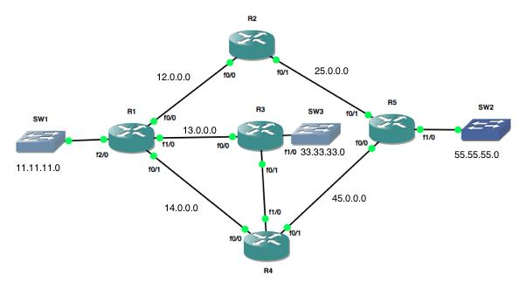
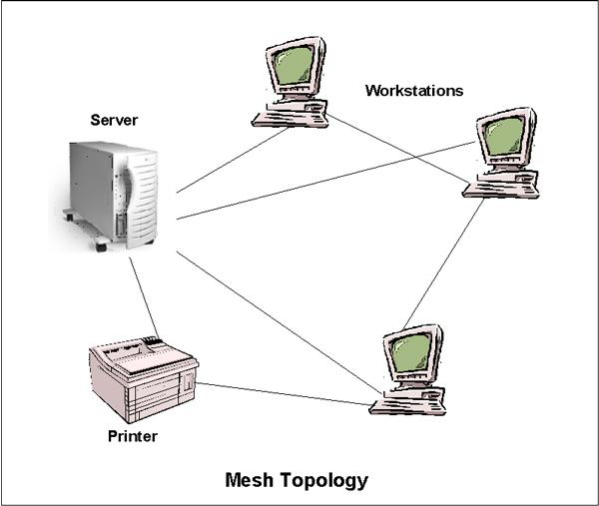
- Multiple connections between devices
- Very reliable

POSSIBLE MID EXAM QUESTIONS

QUESTION 1 — BASIC STAR TOPOLOGY + PING

Task
Create a star topology using:
- 1 switch
- 4 PCs
Assign:
PC1 → 192.168.1.2
PC2 → 192.168.1.3
PC3 → 192.168.1.4
PC4 → 192.168.1.5
Subnet → 255.255.255.0

Requirements
- Connect all PCs with copper straight-through cable
- Verify connectivity using ping

What Teacher Checks
- Correct topology
- Correct IP assignment
- Successful ping

QUESTION 2 — CLIENT SERVER NETWORK

Task
Create:
- 1 switch
- 1 server
- 3 PCs
Assign:
Server → 192.168.10.1
PC1 → 192.168.10.2
PC2 → 192.168.10.3
PC3 → 192.168.10.4

Requirements
- Connect all devices
- Ping server from all PCs

QUESTION 3 — DHCP SERVER CONFIGURATION

MOST IMPORTANT QUESTION
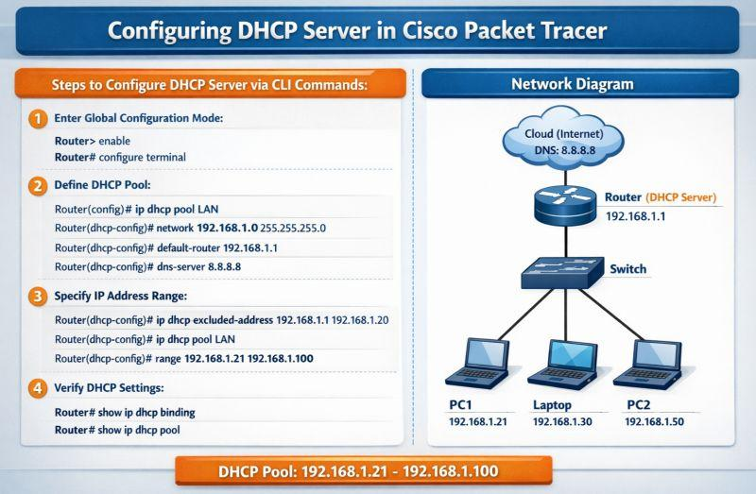
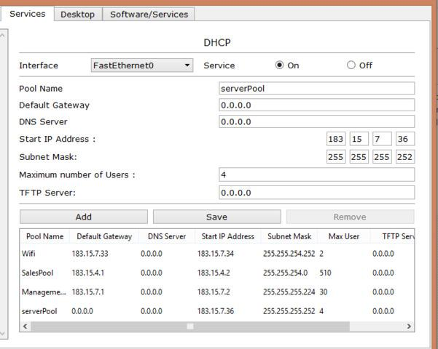
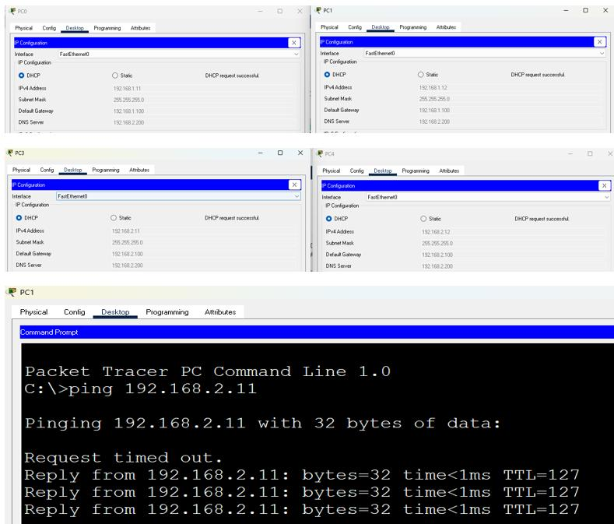
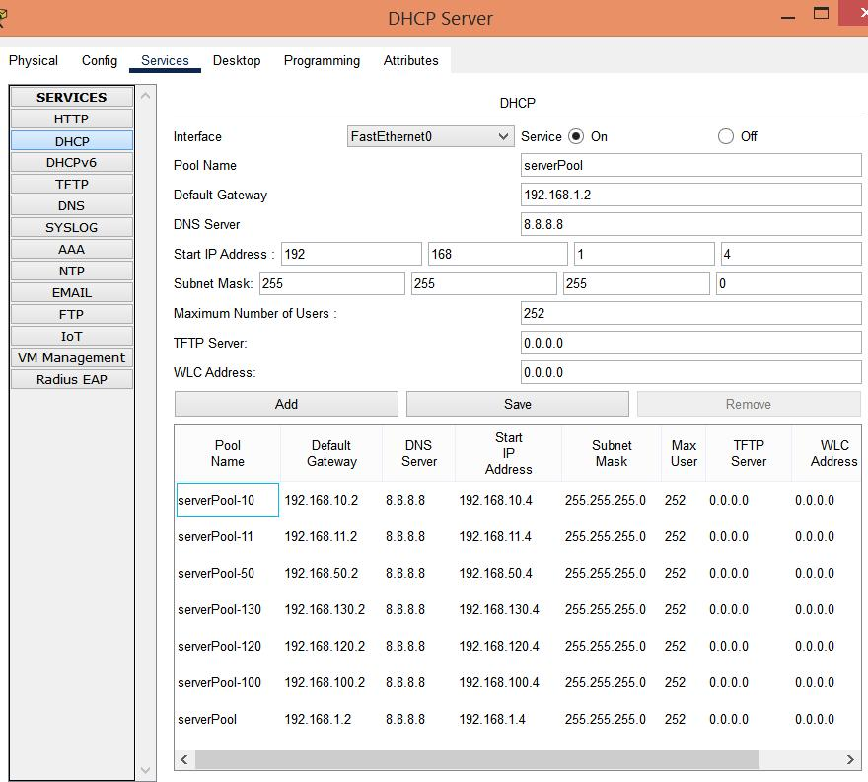
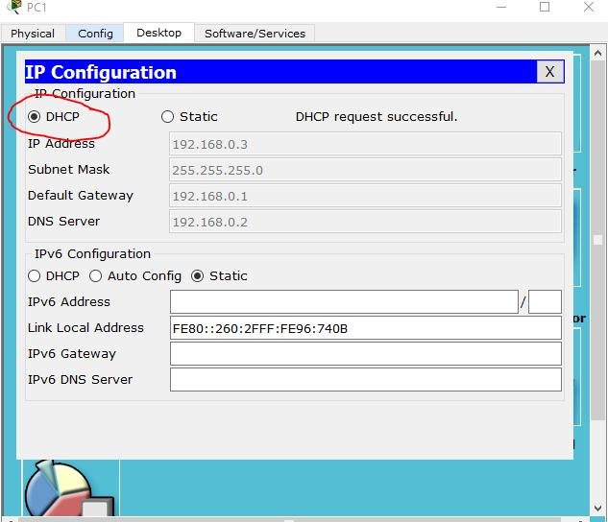
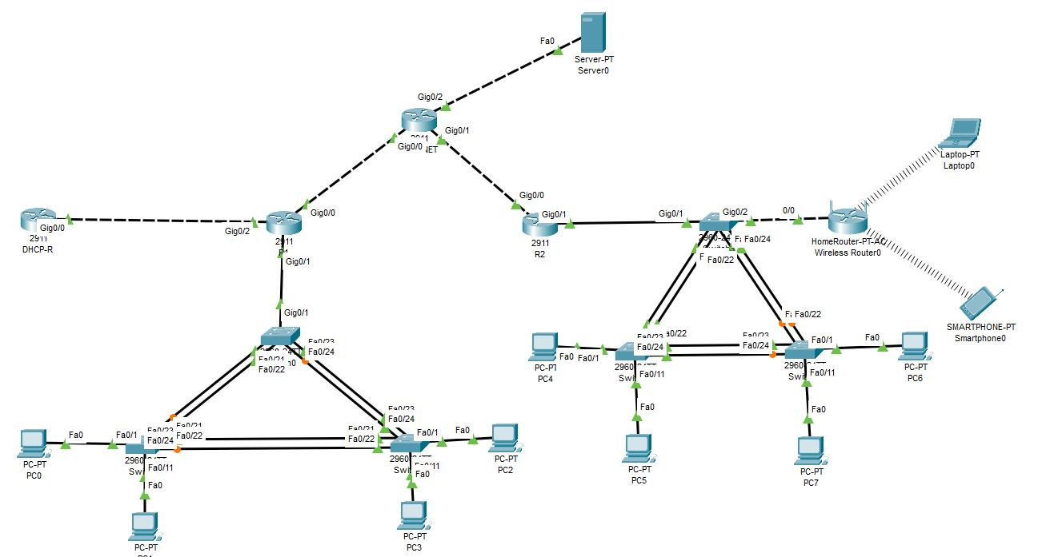

Task
Create:
- 1 router
- 1 switch
- 4 PCs
Router acts as DHCP server.

Router Configuration
enable
configure terminal

interface gig0/0
ip address 192.168.1.1 255.255.255.0
no shutdown
exit

ip dhcp pool LAB
network 192.168.1.0 255.255.255.0
default-router 192.168.1.1
dns-server 8.8.8.8
exit

PC Configuration
Desktop → IP Configuration → DHCP

Expected Result
All PCs automatically get IPs.

QUESTION 4 — MONITOR SWITCH TRAFFIC

Task
- Create star topology
- Send ping packets
- Use simulation mode
- Observe traffic

Teacher May Ask
- MAC address table
- ARP requests
- ICMP packets

Important Command
show mac-address-table

QUESTION 5 — FTP SERVER CONFIGURATION

VERY IMPORTANT
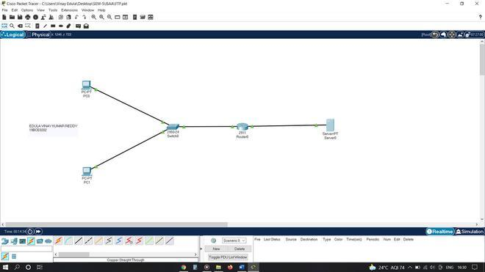
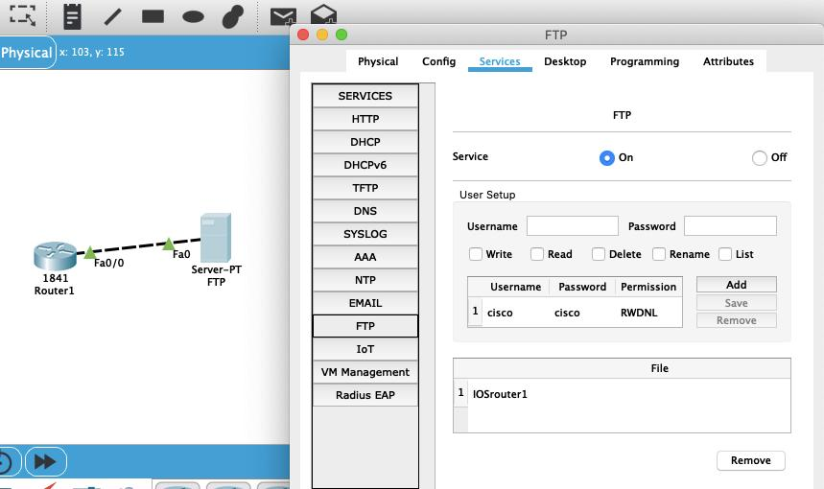
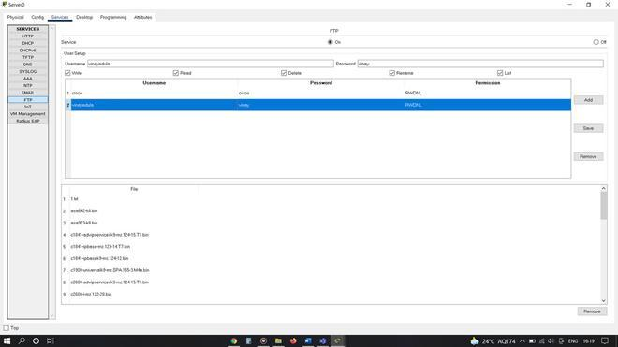
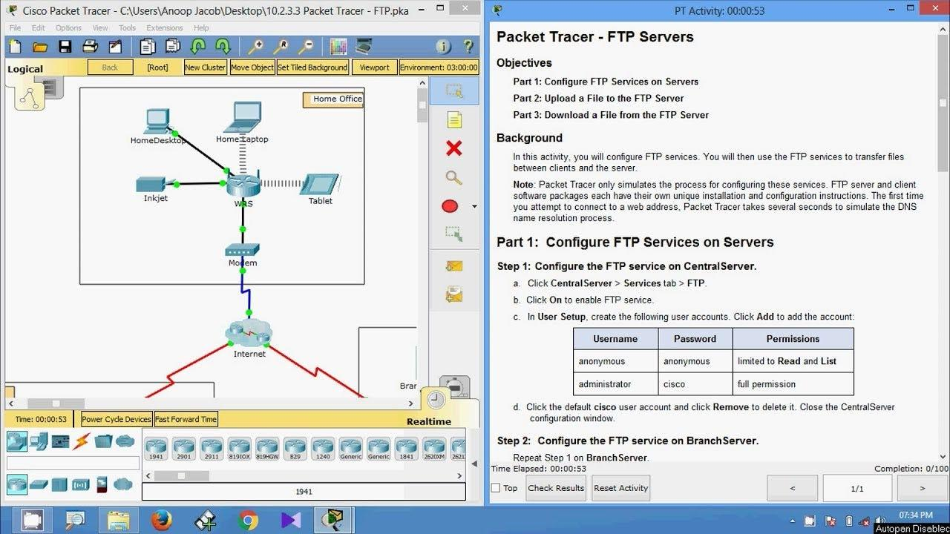
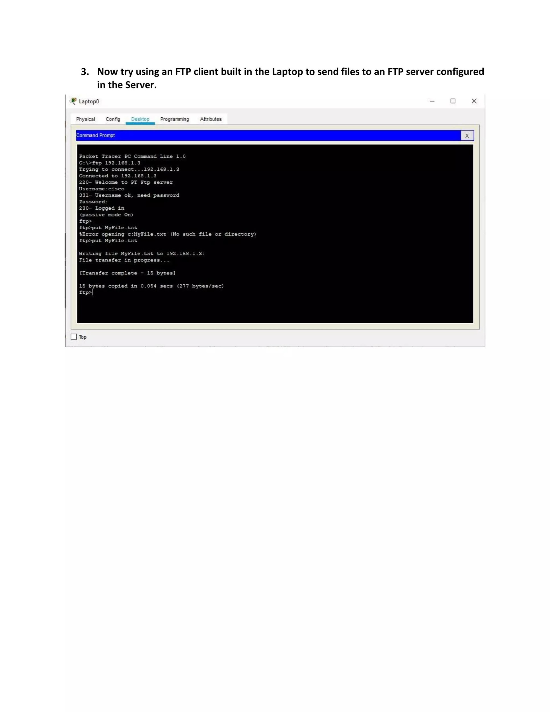

Task
Create:
- 1 server
- 2 PCs
- 1 switch

IPs
Server → 192.168.1.10
PC1 → 192.168.1.2
PC2 → 192.168.1.3

Steps

On Server
Services → FTP → ON
Create:
username: admin
password: 123

On PC
Desktop → Command Prompt
ftp 192.168.1.10

Enter username/password.

QUESTION 6 — TWO ROUTERS STATIC ROUTING

MOST EXPECTED QUESTION
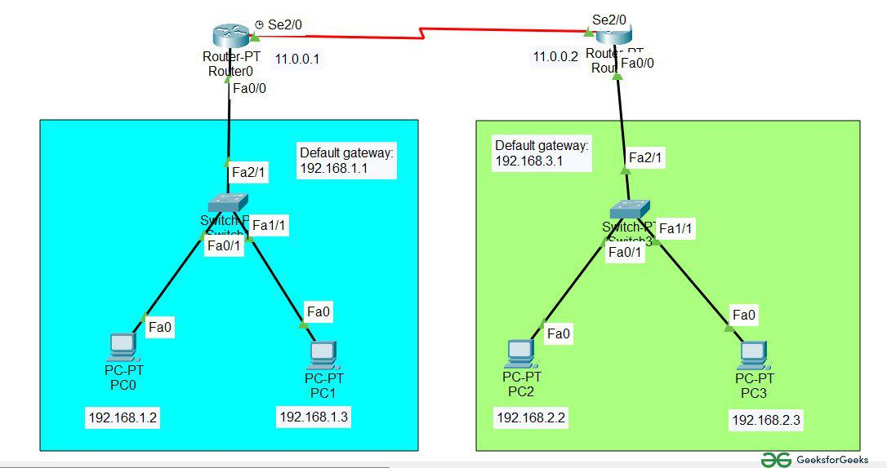
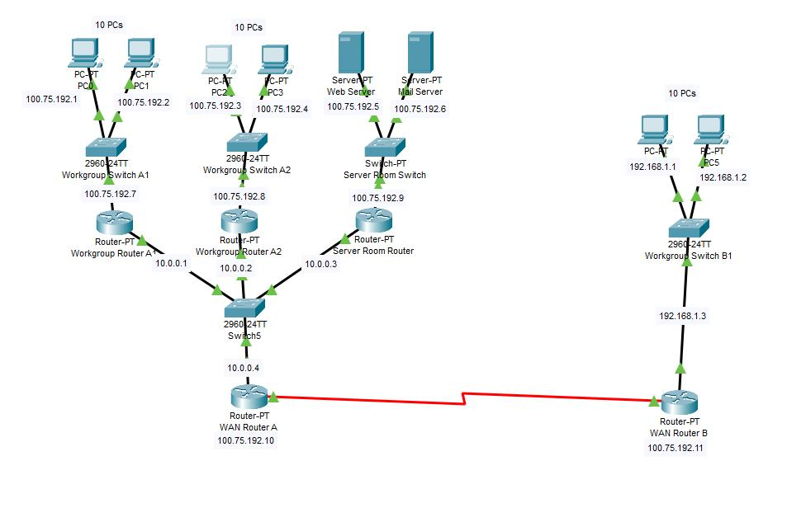
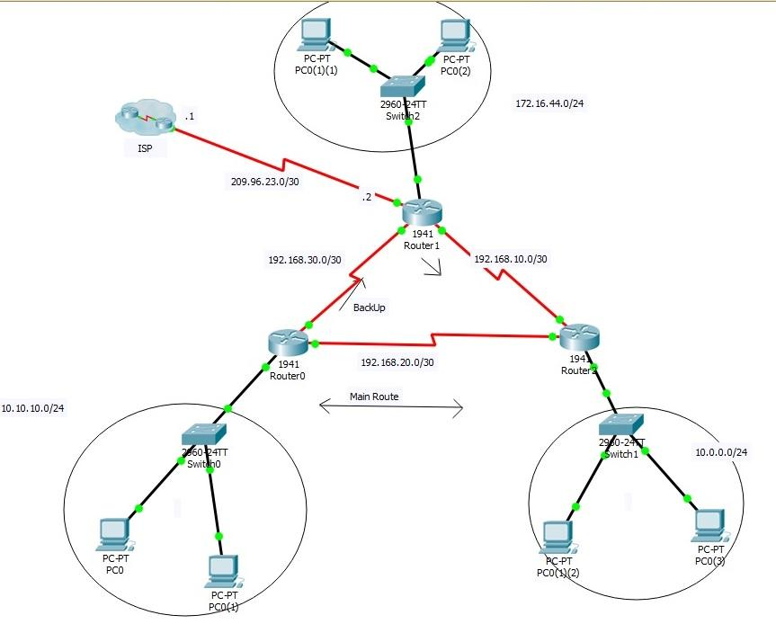
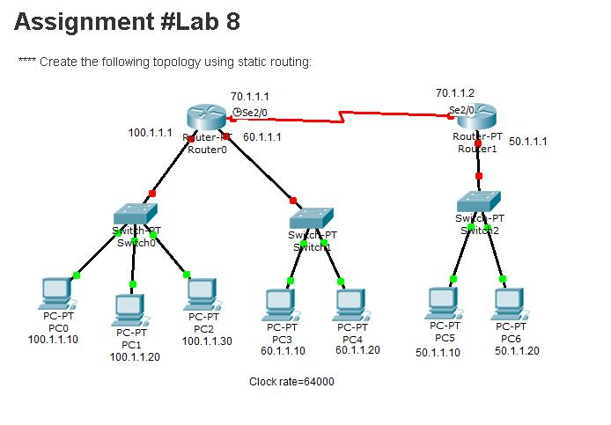
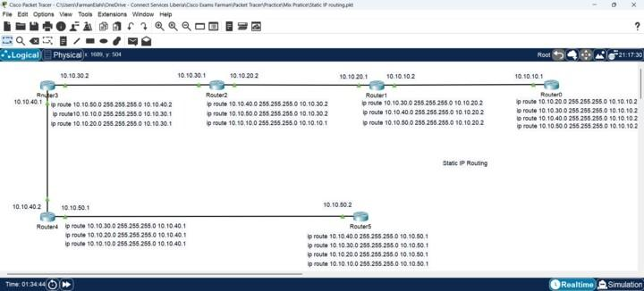
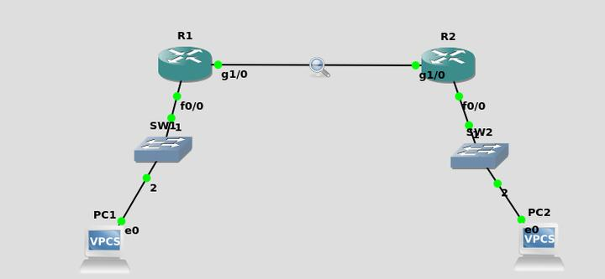

Topology
PC --- Router1 --- Router2 --- PC

IP Scheme

LEFT NETWORK
PC1 → 192.168.1.2
Gateway → 192.168.1.1

RIGHT NETWORK
PC2 → 192.168.2.2
Gateway → 192.168.2.1

ROUTER CONNECTION
R1 → 10.0.0.1
R2 → 10.0.0.2

Router 1 Config
enable
configure terminal

interface gig0/0
ip address 192.168.1.1 255.255.255.0
no shutdown
exit

interface gig0/1
ip address 10.0.0.1 255.255.255.252
no shutdown
exit

ip route 192.168.2.0 255.255.255.0 10.0.0.2

Router 2 Config
enable
configure terminal

interface gig0/0
ip address 192.168.2.1 255.255.255.0
no shutdown
exit

interface gig0/1
ip address 10.0.0.2 255.255.255.252
no shutdown
exit

ip route 192.168.1.0 255.255.255.0 10.0.0.1

TEST
From PC1:
ping 192.168.2.2

If ping works → configuration correct.

QUESTION 7 — SUBNETTING QUESTION

Example
Given:
IP = 192.168.1.0/27

Find:
- Network ID
- Broadcast ID
- Number of hosts

Quick Formula
2^n - 2
Where:
- n = host bits
For /27:
32 - 27 = 5
2^5 - 2 = 30 hosts

QUESTION 8 — DIAGNOSING NETWORK ERRORS

Teacher May Intentionally Break:
- Wrong subnet mask
- Wrong gateway
- Interface shutdown
- Wrong cable

You Must Check
show ip interface brief

If interface is:
administratively down

Use:
no shutdown

QUESTION 9 — DIFFERENT TOPOLOGY USING 2 ROUTERS

Possible Variation
Create:
- Mesh topology
- Ring topology
- Star topology
Using:
- 2 routers
- 2 switches
- 4 PCs
Then:
- Configure static routing
- Test connectivity

QUESTION 10 — COMPLETE COMBINED QUESTION (VERY POSSIBLE)

FULL LAB QUESTION
Create a network using:
- 2 routers
- 2 switches
- 1 server
- 4 PCs
Requirements:
- Use star topology
- Configure static routing
- Configure DHCP
- Configure FTP server
- Test connectivity
- Verify using ping
This is the most complete form of your syllabus.

MOST IMPORTANT THINGS TO REMEMBER

1. ALWAYS DO THIS
no shutdown

2. ALWAYS SET DEFAULT GATEWAY
PC gateway must be router IP.

3. STRAIGHT CABLE
Use:
PC ↔ Switch
Switch ↔ Router

4. CROSSOVER CABLE
Use:
Router ↔ Router

(Some Packet Tracer versions auto-select.)

MOST IMPORTANT COMMANDS FOR MID

Router
enable
configure terminal
interface
ip address
no shutdown
ip route
show ip route
show ip interface brief

PC
ping
ipconfig
ftp

